AWS Structure and Workflow Documentation

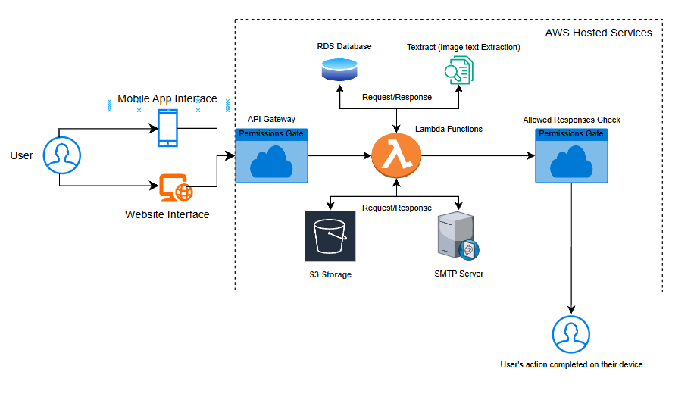

### **AWS Services Used**

The following AWS components are central to the system:

**1. AWS Lambda** Handles all backend logic in a serverless environment. Functions are triggered by events from the API Gateway and perform operations such as database interactions, file storage, and document processing.

**2. API Gateway** Serves as the primary entry point for both mobile and web client requests. It routes incoming requests to the appropriate Lambda functions and includes access control through a permissions layer.

**3. Amazon RDS (Relational Database Service)** Used for storing structured application data. Lambda functions interact with RDS to read and write user and system information.

**4. Amazon Textract** Processes images submitted by users to extract text data. This supports features like automated form processing or receipt scanning.

**5. Amazon S3** Used for storing and retrieving user-uploaded files such as images and documents.

### **System Workflow**

**1. User Request** A user interacts with either the mobile app or the website interface. Their action triggers a request sent to the API Gateway.

**2. Request Authorization** The API Gateway first checks the request against a permissions gate to ensure the action is allowed.

**3. Backend Processing** If authorized, the request is forwarded to a Lambda function, which performs the required logic. This may include:

* Querying the RDS database
* Sending an image to Textract for processing
* Uploading or retrieving files from S3

**4. Response Validation** After processing, the Lambda function returns the result. A second permissions gate checks that the response is valid for the user.

**5. Action Completion** The validated response is returned to the user's device, completing the workflow.